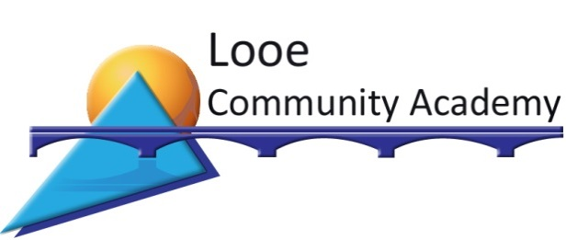

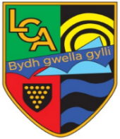

Sunrising, East Looe, Cornwall PL13 1NQ
Telephone: 01503 262625
Email: enquiries@looeca.net
www.looe.cornwall.sch.uk

Headteacher: Mr S Yalden BSc (Hons) PGCE NPQH
May 2022

Dear Parent/Carer

Transition to Year 7
Induction Day and Evening - Tuesday 27 June

Further to my letter of 2 May, I am writing to provide further information about our Induction Day and Evening and to also ask you to complete the necessary paperwork ahead of your child joining us in September.

Our Induction Day for new Year 7 students is on Tuesday 27 June. Your child is invited to spend the day with us starting at 8.40am. The purpose of this visit is to introduce your child to their tutor group peers, and to some of the staff who will be working with them. In addition, it enables each student to have a closer look at the school and its routines. Normal primary school uniform should be worn.
Refreshments will be available from the canteen for breakfast and at break and lunchtime and we suggest your child brings money unless they are bringing a packed lunch. We provide a variety of main meals, sandwiches, snacks, drinks and meal deals, as a guide, the main meal plus dessert is £2.50. Weather permitting, outdoor games may be part of the programme, pens and pencils will also be required.

I would also like to invite you to attend the parents’/carers’ Induction Evening which will also be on Tuesday 27 June. The presentation will begin at 6pm in the Main Hall. This will be followed by information from the Leadership Team, an opportunity to ask questions and try on school uniform blazers for sizing, prior to ordering from our online suppliers. You will also be given a summary of the Academy Information Booklet detailing school procedures and routines and staff will be available to meet you. Your child is also welcome to attend.

If your child qualifies for free school meals, please apply online at https://www.cornwall.gov.uk/schools-and-education/schools-and-colleges/school-meals/apply-for-free-school-meals-and-pupil-premium/
I am aware that some families do not claim free school meals, which they may be entitled to. The Government’s Pupil Premium means that the school will receive £935 for each child who is eligible for free school meals, even if your child chooses not to take up the free school meal offer. This money will help us to support children with additional resources. If you are unable to apply online, please call the free school meals team at Cornwall Council on 01872 323298 and a member of their team will call you back to complete the application over the phone.

We are pleased to advise that the Academy operates a cashless catering system which offers you several payment options including credit and debit cards and PayPoint. Our system also allows you to monitor your child’s food purchases. Further details are enclosed together with a consent form should you wish your child to use the biometric payment method at the till.

Enclosed with this letter you will find information together with important forms for completion. Also enclosed is a pre-paid envelope for the return of these and we would be grateful if you could do this as soon as possible for us and no later than Friday 9 June.

The first day for students will be Wednesday 6 September 2023 and the term dates are listed below for your information.

If we can be of any assistance at this time, please do not hesitate to contact us and we very much look forward to welcoming you and your child.

Yours faithfully
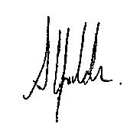
Mr Scott Yalden
Headteacher

Enclosed with this letter | To complete and return in the enclosed  pre-paid envelope
Admissions form | Y
Image consent form | Y
Cashless catering consent form | Y
School closure and snowy weather instructions | Y
Requests for absence information
Allergens
Privacy notice
Pupil Premium information
School dog information
Key to Success information
Cashless catering information
Pre-paid envelope

2023-24 term dates

Autumn term
Monday 4 September – Tuesday 19 December (half term 23-27 October)

Spring term
Thursday 4 January – Thursday 28 March (half term 12-16 February)

Summer term
Monday 15 April – Wednesday 24 July (half term 27-31 May)

The following are INSET days when the Academy is closed to students:
Monday 4 September
Tuesday 5 September
Friday 24 November
Thursday 4 January
Monday 19 February
Friday 21 June

